**­Part 2**

At first, the user enters the transformation matrix.

Here the second approach is considered, wherein we loop over all the destination pixels and copy the appropriate pixels from the source image.

In order to do this, we need to find the inverse of the transformation matrix and then identify the correct x, y positions. (x,y) in source is copied to the destination which is iterated over (i,j).

The first approach doesn’t provide desirable results. The warped image contains noise.

 

Input Image Output Image

**Part 3**

Threshold = 100

Number of SIFT descriptors for similar images are in the range of 4000.

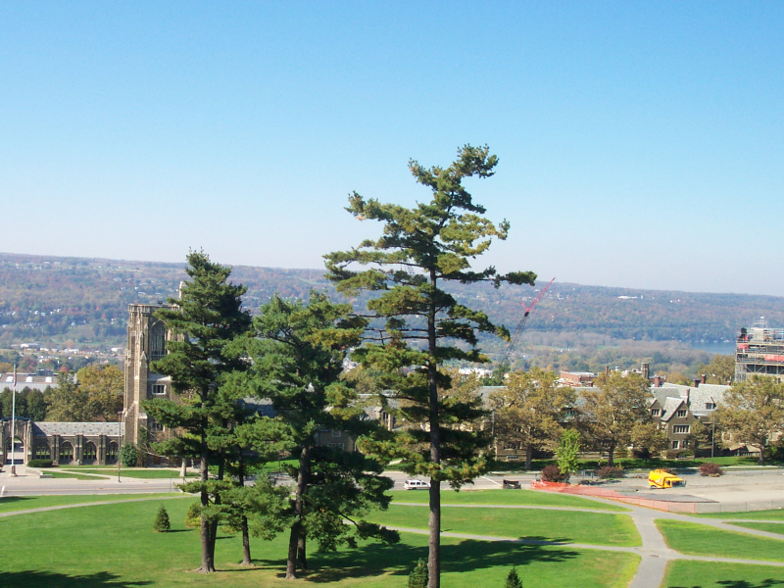 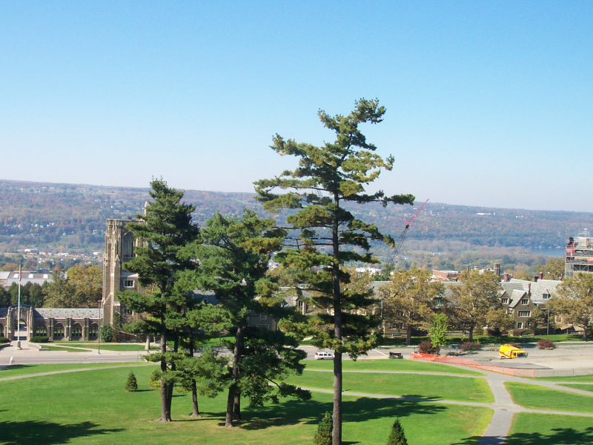

Input Image 1 Input Image 2

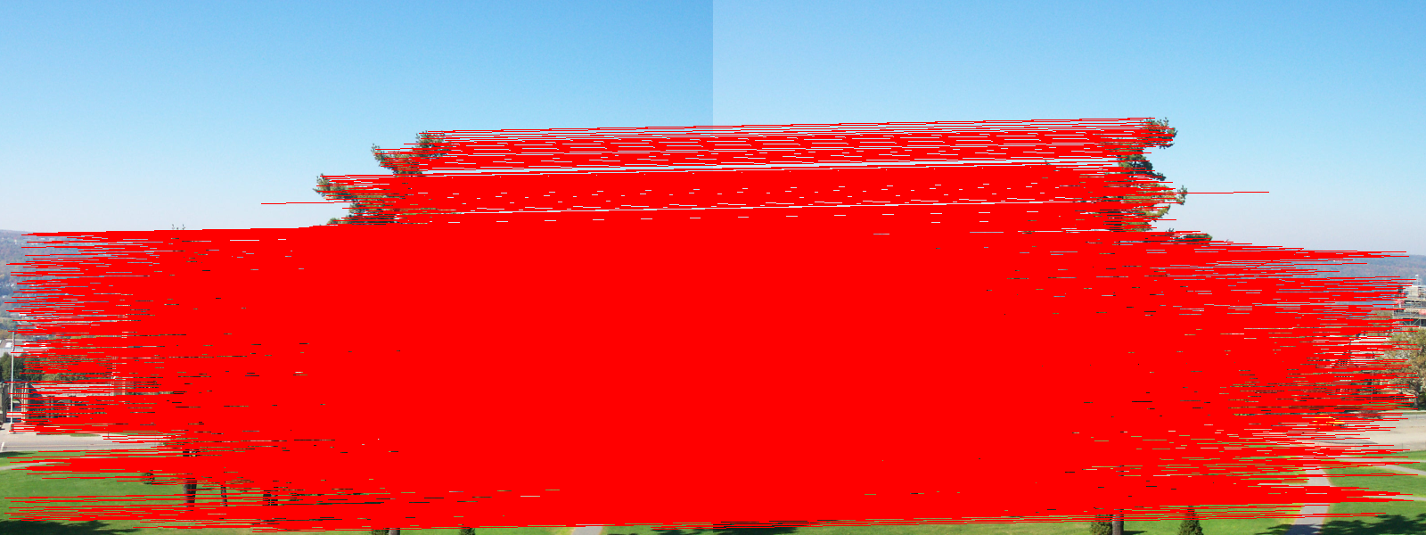

Output Image

In part 3.3

|  |  |  |
| --- | --- | --- |
| Name | No. of Matches | Percent (in top 10) |
| BigBen_3 | 3 | 30% |
| Colosseum_12 | 1 | 10% |
| Eiffel_22 | 4 | 40% |
| Londoneye_2 | 4 | 40% |
| Trafalgarsquare_20 | 2 | 20% |
| Sanmarco_5 | 4 | 40% |
| Empirestate_9 | 3 | 30% |
| Louvre_4 | 2 | 20% |
| Notredame_24 | 2 | 20% |
| Tatemodern_2 | 3 | 30% |

In the code for 3.3, the path for attraction_images folder is given.

**Part 4**

In part 4.1, the ratio of closest to second closest distance is considered to be 0.5.

The result is slightly better than the ones seen in part 3. We can see that there are fewer undesirable matches than in part 3.

In part 4.2, x and y displacement values are stored in a vector and the mean for both dimensions are calculated.

In part 4.3, random x and y values are picked for 10 times and the pair with the highest matching count is considered as the final displacement pair.

In part 4.4, except for the pair falls_1.png & falls_2.png, stitching algorithm works accurately.

In this pair, the combining area is seen.

This might due to two reasons.

1. There might be another transformation in addition to translation between the two images.
2. In the displacement values approximation, there might be very few matching (or near matching values) and the randomly selected index might not have chosen the right displacement. Even if selected, since there might varied displacement value candidates, the right displacement candidate might not have obtained the highest vote. Increasing the number of such iterations could have given better results, but I observed that the speed of execution was greatly affected.

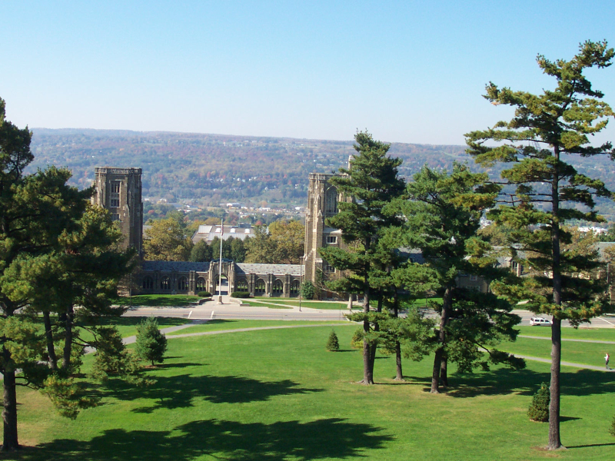 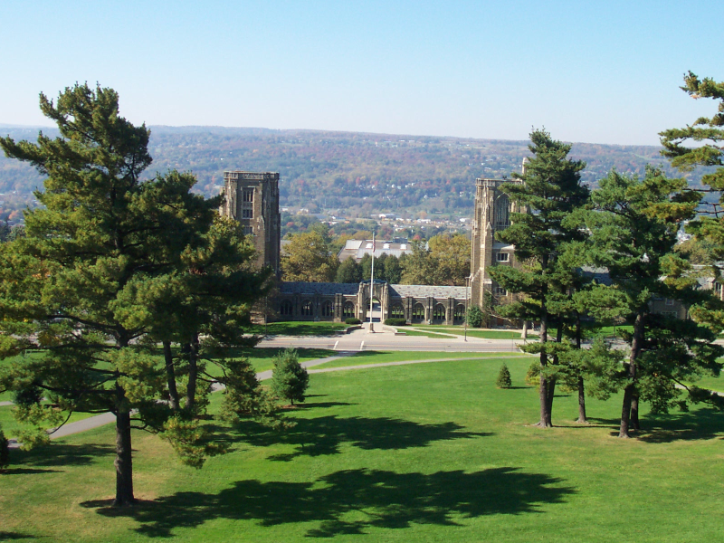

Input Image 1 Input Image 2

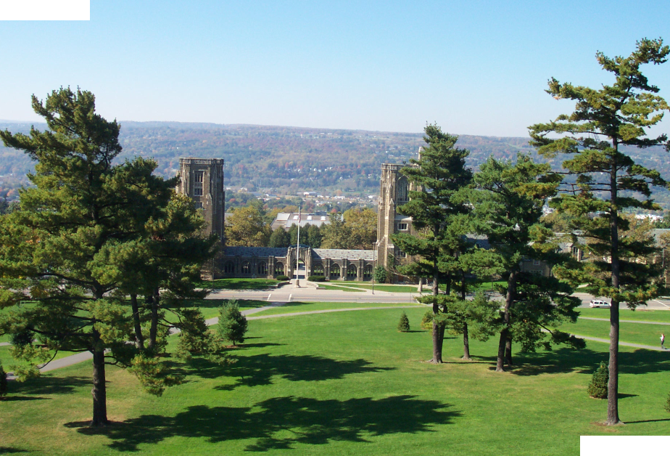

Output: Stitched Image